Assignment 7.3

Create a box and whisker plot by class using mtcars dataset.

Solution: -

**Using Base Graphics**

boxplot(data=mtcars, mpg ~ cyl,

xlab = "Cylinder", ylab = "Milage Per Galon", main = "MPG vs CYL")

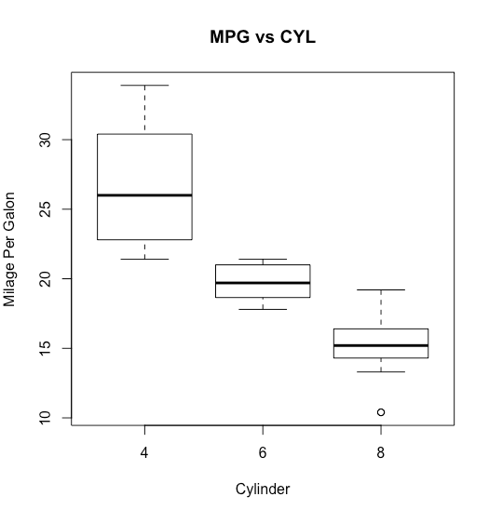

**Using Lattice Graphics**

library(flexclust)

bwplot(data=mtcars, mpg ~ wt,

xlab = "Cylinder", ylab = "Milage Per Galon", main = "MPG vs CYL")

